Data Provider in selenium

1. Using normal data provider
2. Excel
3. Json file
4. Normal

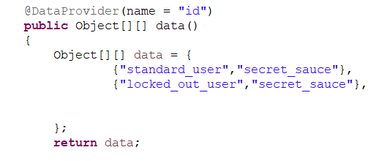

1. excel

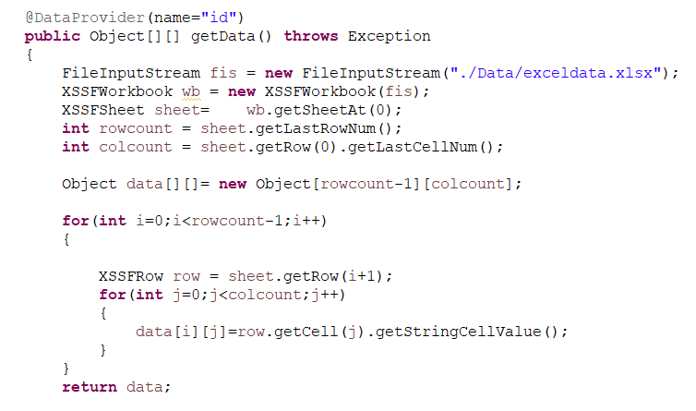

1. JSON

Get dependencies - json-simple

